1. Set up and Configuration Hadoop Using CloudEra/ Google Cloud BigQuery. Databricks
Lakehouse Platform. Snowflake. Amazon Redshift.
2. Develop a MapReduce program to calculate the frequency of a given word in a given file.
3. Implement Matrix Multiplication using Map-Reduce
4. Develop a MapReduce program to find the grades of students.
5. Develop a MapReduce program to analyze Titanic ship data and to find the average age of the
people (only male) who died in the tragedy. How many persons are dead in each class (only female).
6. Mongo DB: Installation and Creation of database and Collection CRUD Document: Insert, Query,
Update and Delete Document.
7. Hive: Introduction Creation of Database and Table, Hive Partition, Hive Built in Function and
Operators, Hive View and Index.
8. Visualization: Connect to data, Build Charts and Analyze Data, Create Dashboard, Create Stories
using Tableau/PowerBI.

Experiment 1: Setup & Configuration of Big Data Platforms

🎯 Aim
To study and perform the setup/configuration of Big Data tools including Hadoop (Cloudera), Google BigQuery, Databricks Lakehouse, Snowflake, and Amazon Redshift.

📚 Theory

🔹 Hadoop (Cloudera)
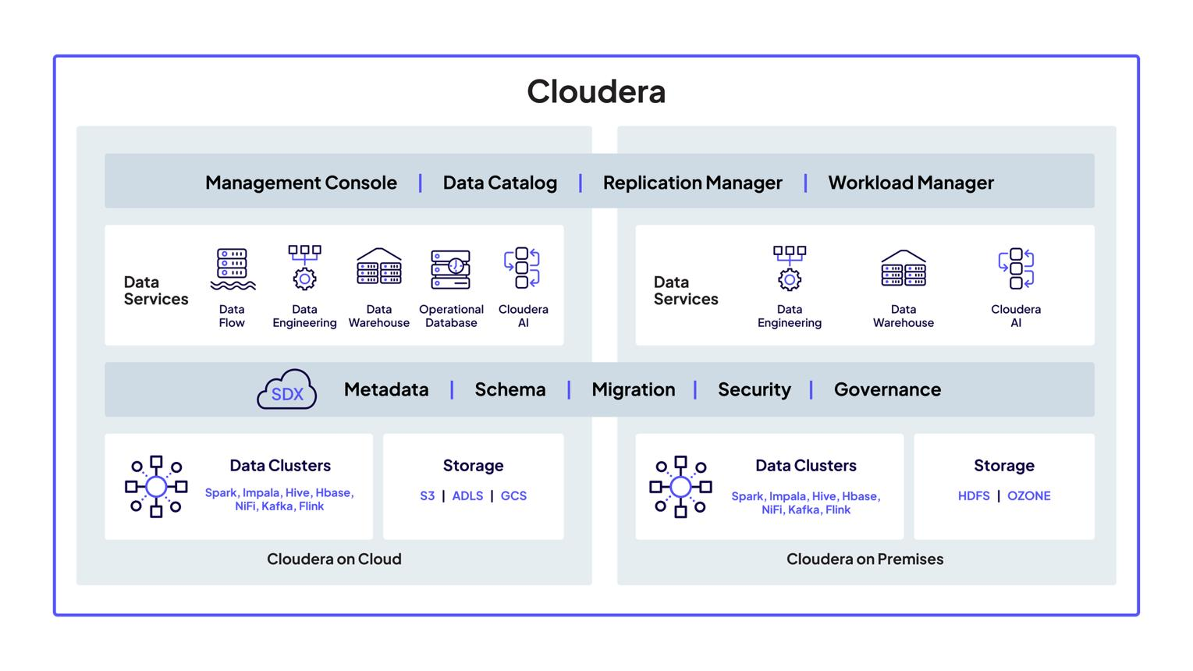

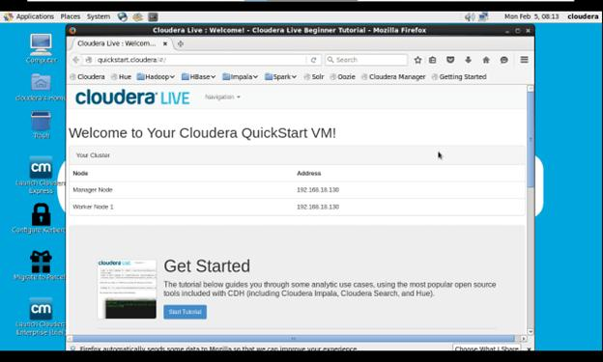
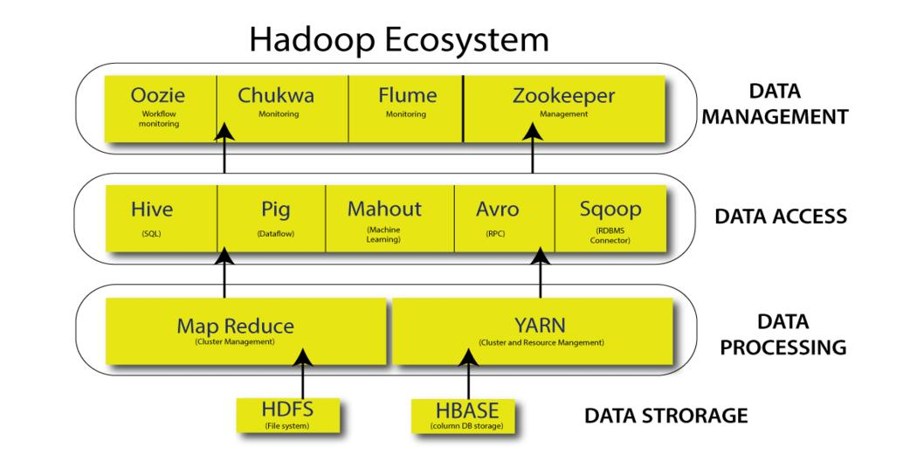
6
- Apache Hadoop is an open-source framework for distributed storage & processing.
- Cloudera provides Hadoop distribution (CDH).
- Core components:
  - HDFS (storage)
  - YARN (resource management)
  - MapReduce (processing)

🔹 Google BigQuery
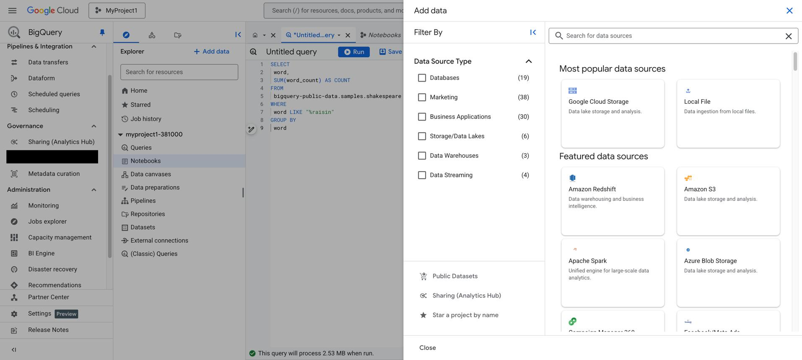
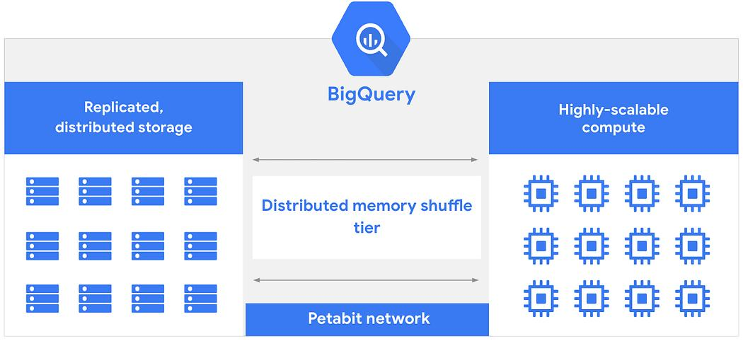
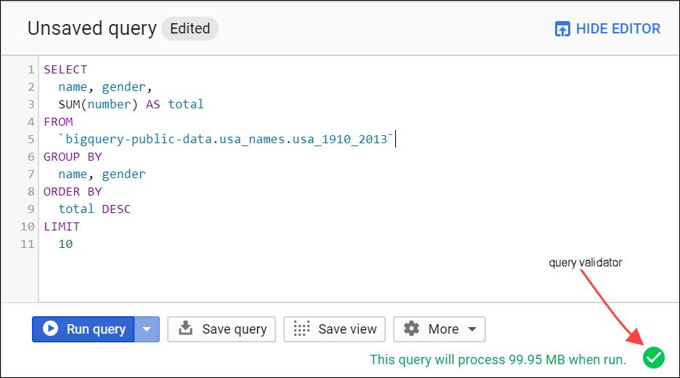
5
- Google BigQuery is a serverless, highly scalable data warehouse.
- Part of Google Cloud Platform
- Uses SQL for querying massive datasets.

🔹 Databricks Lakehouse Platform
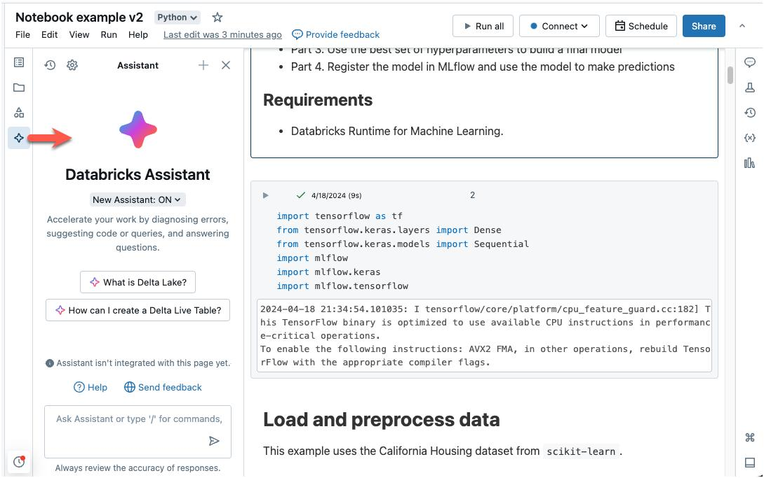
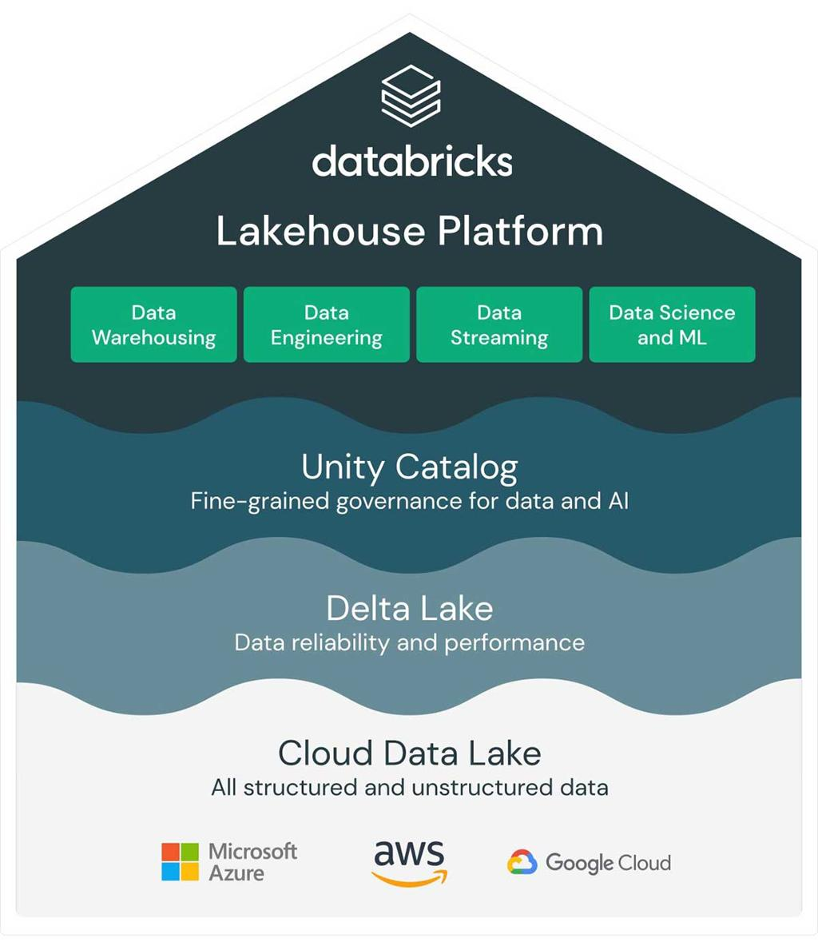
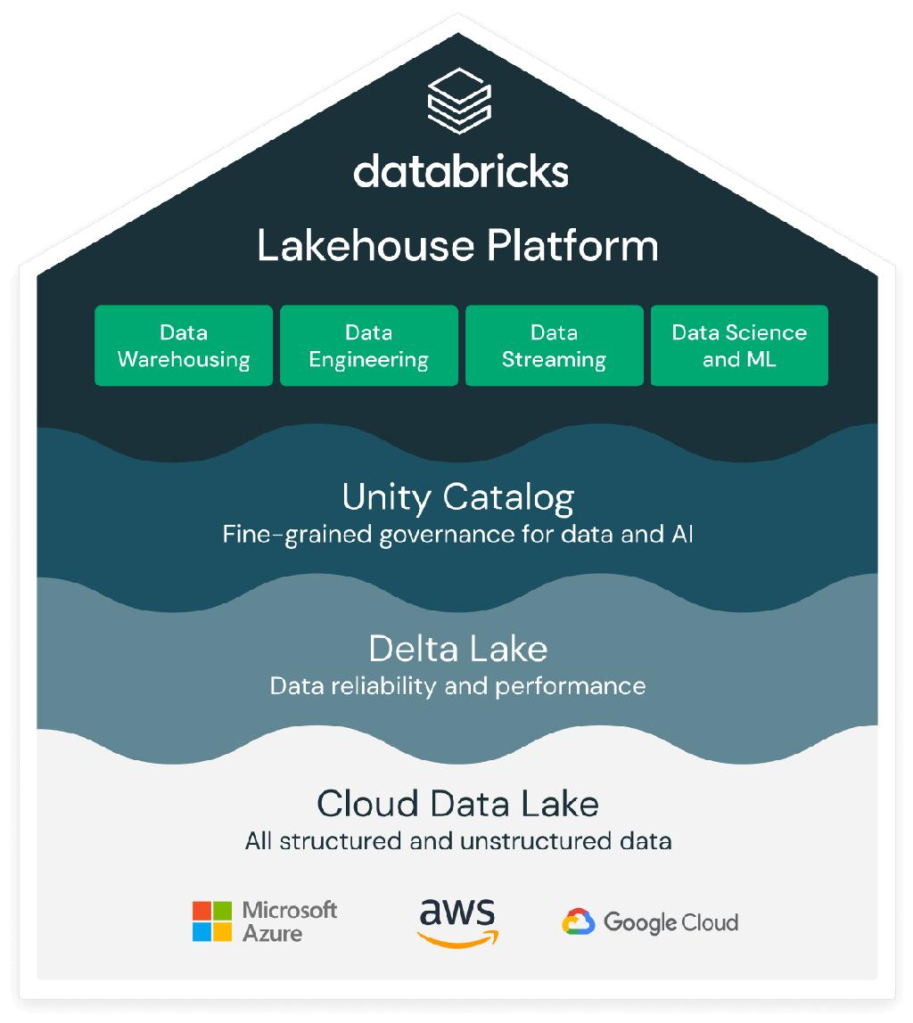
6
- Databricks provides unified analytics platform.
- Built on Apache Spark
- Combines Data Lake + Data Warehouse (Lakehouse).

🔹 Snowflake
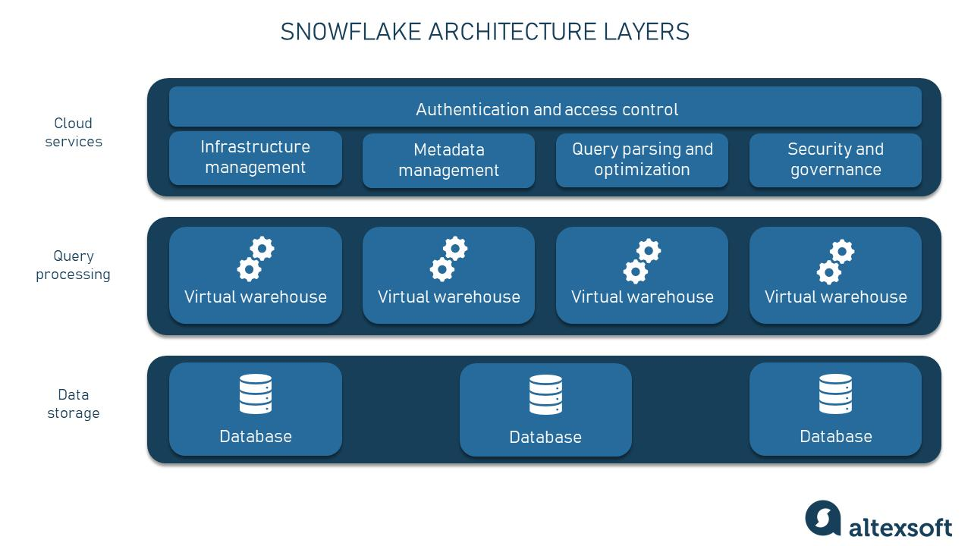
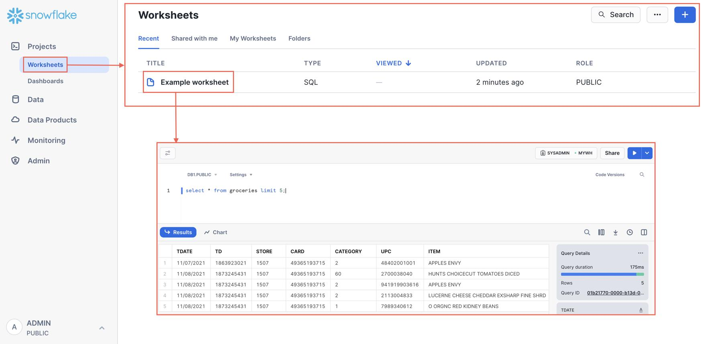
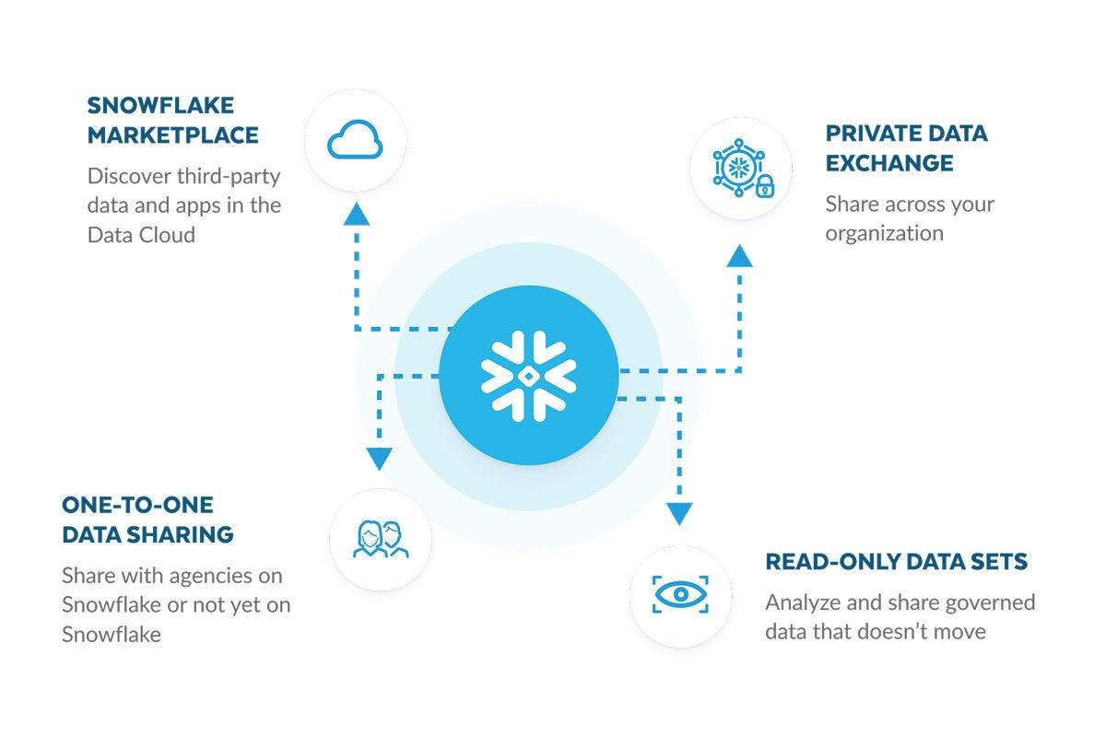
6
- Snowflake Inc. provides cloud-native data warehouse.
- Features:
  - Separation of compute & storage
  - Auto scaling
  - Secure data sharing

🔹 Amazon Redshift
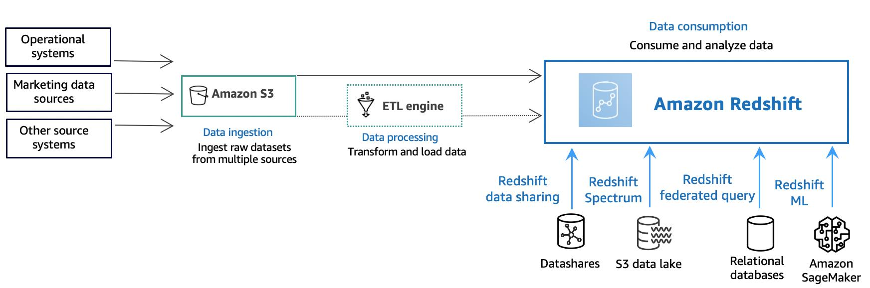
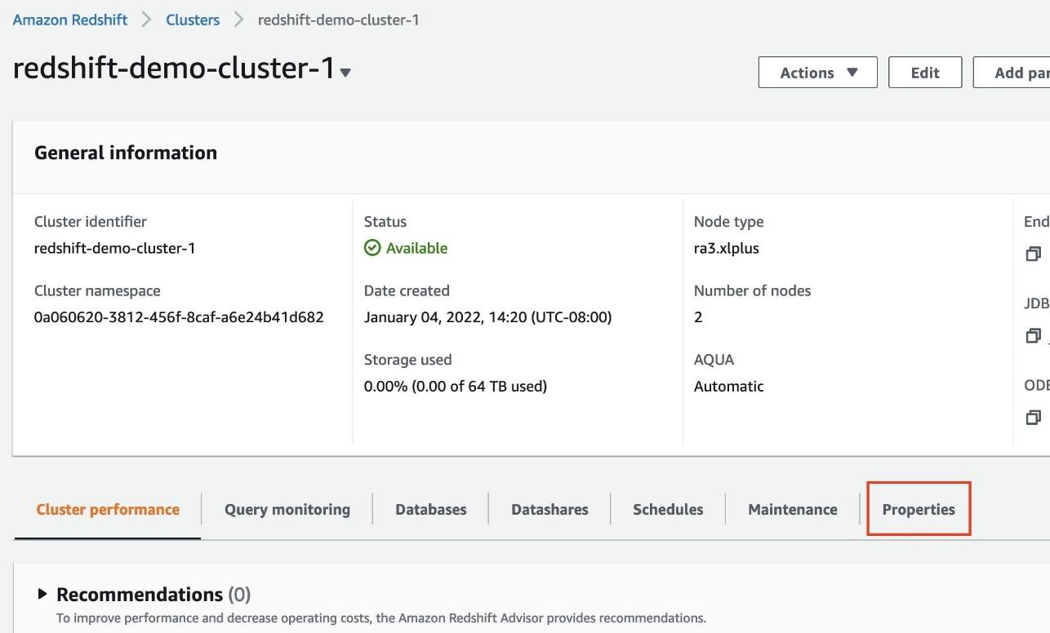
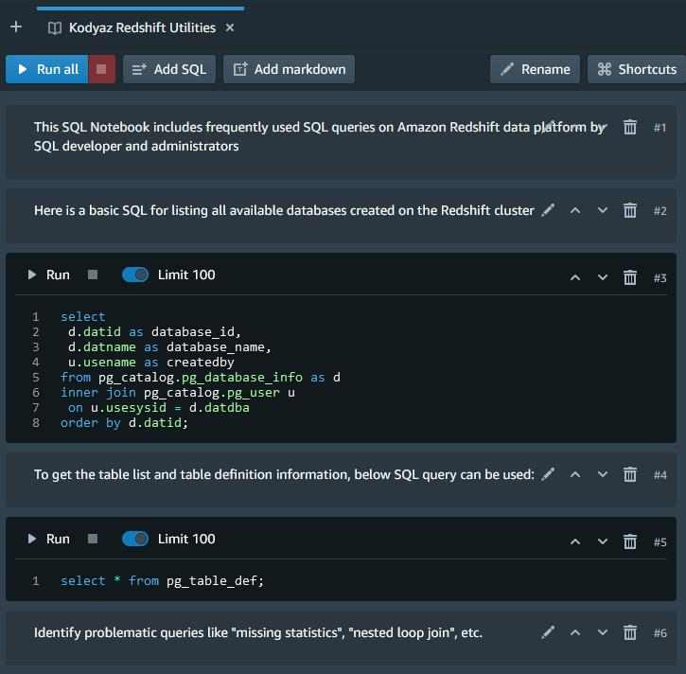
6
- Amazon Redshift is part of Amazon Web Services
- Uses columnar storage and parallel query execution.

🧰 Tools Required
- Internet connection
- Laptop (8GB RAM recommended)
- Accounts on cloud platforms

⚙️ Procedure

🔸 1. Hadoop using Cloudera
- Download Cloudera QuickStart VM
- Install Oracle VirtualBox
- Import VM and start
- Open browser → http://localhost:8888
- Run sample Hadoop jobs

🔸 2. Google BigQuery
- Go to Google Cloud Console
- Create project
- Enable BigQuery API
- Open BigQuery → Create dataset
- Run SQL query:
SELECT * FROM `bigquery-public-data.samples.shakespeare`
LIMIT 10;

🔸 3. Databricks Lakehouse
- Sign up on Databricks Community Edition
- Create workspace
- Launch cluster
- Create notebook
- Run sample:
spark.range(10).show()

4. Snowflake
- Create Snowflake account
- Login → Worksheets
- Create database:
CREATE DATABASE test_db;
- Run queries

🔸 5. Amazon Redshift
- Login to AWS Console
- Open Redshift service
- Create cluster
- Connect using Query Editor
- Execute SQL queries

📊 Observations
- Successfully accessed all platforms
- Executed sample queries/jobs
- Compared interfaces and performance

✅ Result
Big Data platforms (Hadoop, BigQuery, Databricks, Snowflake, Redshift) were successfully configured and tested.

📌 Conclusion
- Understood differences between on-premise (Hadoop) and cloud platforms
- Learned basics of modern data warehousing tools

iment 2: MapReduce Program for Word Frequency

Aim
To develop a MapReduce program to calculate the frequency of a given word in a file using Apache Hadoop.

📚 Theory

🔹 What is MapReduce?
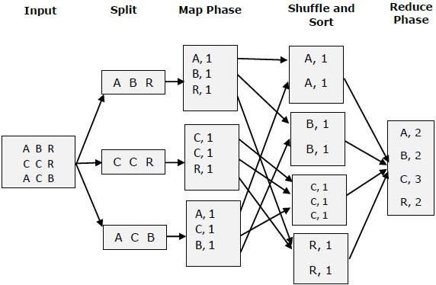
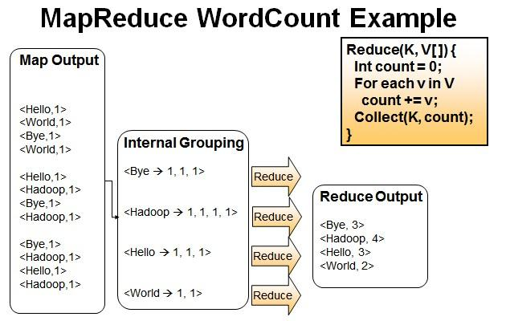
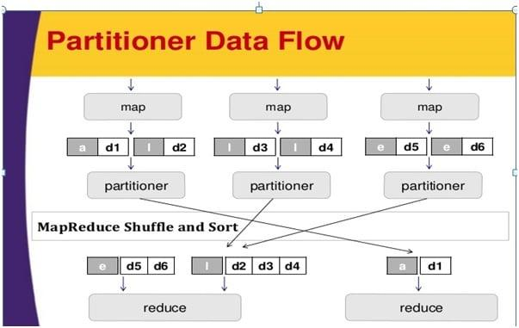
5
- MapReduce is a programming model used in Hadoop for processing large datasets.
- It consists of two main phases:

🔸 Map Phase
- Reads input data
- Converts text into key-value pairs

Example:

Input: Hello World Hello
Output: (Hello,1), (World,1), (Hello,1)

🔸 Reduce Phase
- Aggregates values of same key

Example:

(Hello,1,1) → (Hello,2)
(World,1) → (World,1)

🧰 Tools Required
- Hadoop (Cloudera / pseudo-distributed mode)
- Java / Python
- Linux terminal

⚙️ Algorithm
- Read input file
- Split words
- Emit (word,1) pairs in Mapper
- Shuffle & sort
- Count occurrences in Reducer
- Display output

💻 Program (Python MapReduce)

🔹 Mapper Code
#!/usr/bin/env python3
import sys
for line in sys.stdin:
words = line.strip().split()
for word in words:
print(f"{word}\t1")

🔹 Reducer Code
#!/usr/bin/env python3
import sys
current_word = None
current_count = 0
for line in sys.stdin:
word, count = line.strip().split("\t")
count = int(count)
if current_word == word:
current_count += count
else:
if current_word:
print(f"{current_word}\t{current_count}")
current_word = word
current_count = count
if current_word:
print(f"{current_word}\t{current_count}")

▶️ Execution Steps
- Create input file:
echo "hello world hello hadoop" > input.txt
- Run Hadoop Streaming:
hadoop jar $HADOOP_HOME/share/hadoop/tools/lib/hadoop-streaming*.jar \
-input input.txt \
-output output_dir \
-mapper mapper.py \
-reducer reducer.py
- View output:
cat output_dir/part-00000

📊 Output
hadoop 1
hello 2
world 1

✅ Result
Successfully calculated word frequency using MapReduce.

📌 Conclusion
- Learned MapReduce programming model
- Understood distributed processing using Hadoop

Experiment 3: Matrix Multiplication using MapReduce

🎯 Aim
To implement matrix multiplication using the MapReduce model in Apache Hadoop.

📚 Theory

🔹 Matrix Multiplication Concept
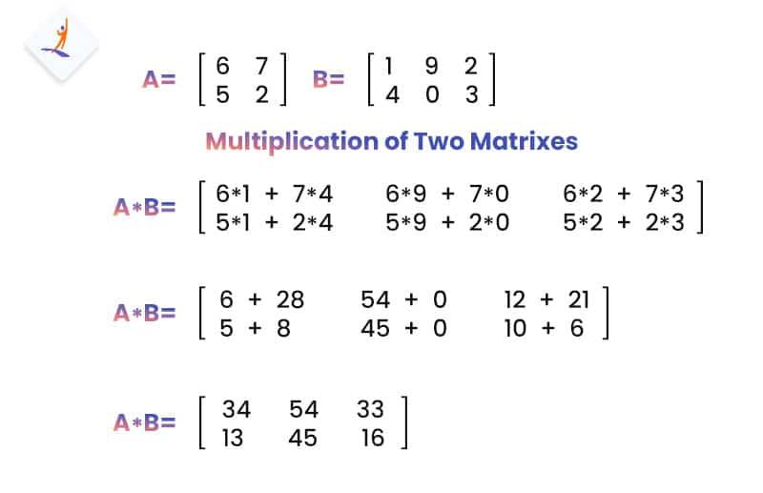
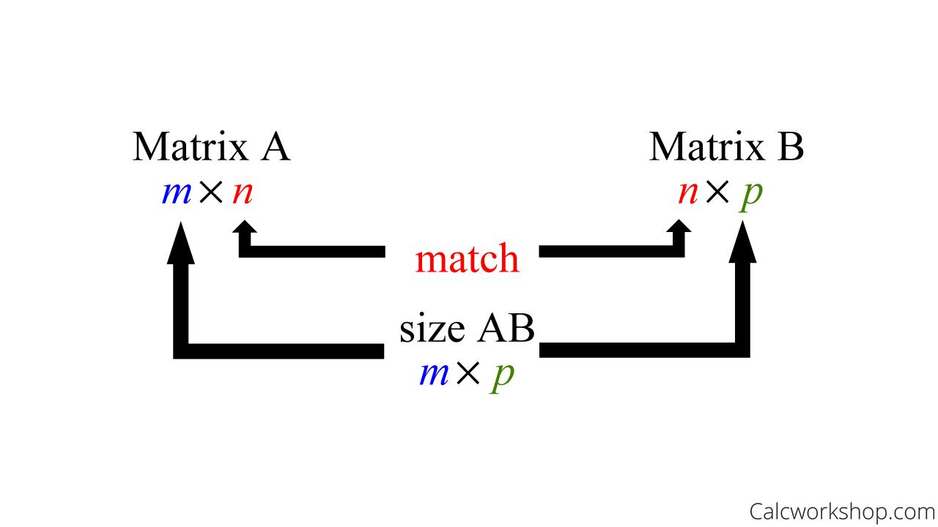
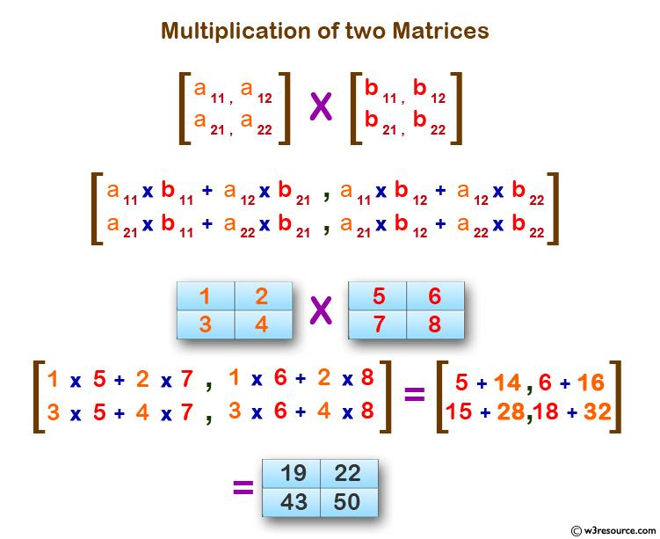
4
If matrix A (m×n) and B (n×p), then result matrix C (m×p) is:

Each element:
- C[i][j]=∑k=1nA[i][k]×B[k][j]C[i][j] = \sum_{k=1}^{n} A[i][k] \times B[k][j]C[i][j]=k=1∑n​A[i][k]×B[k][j]

🔹 MapReduce Approach
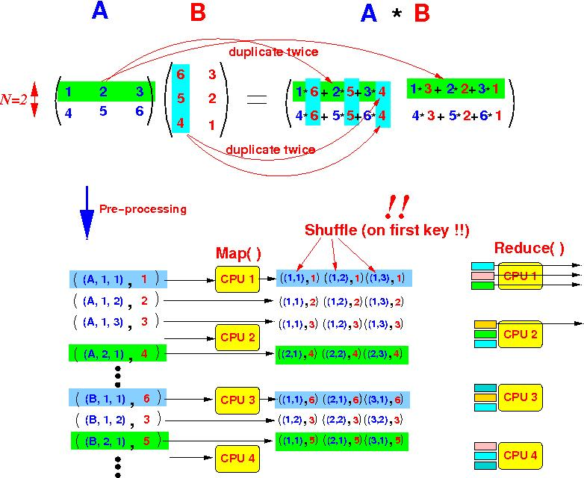
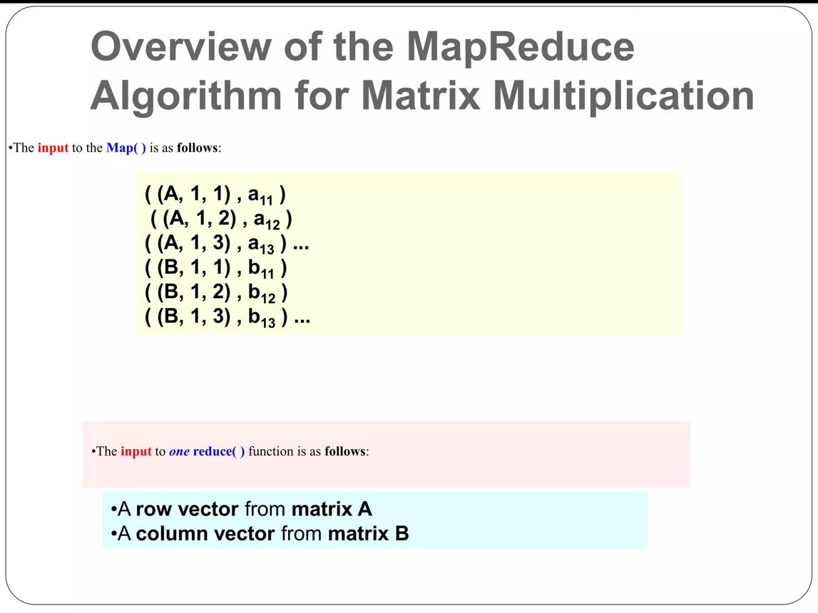
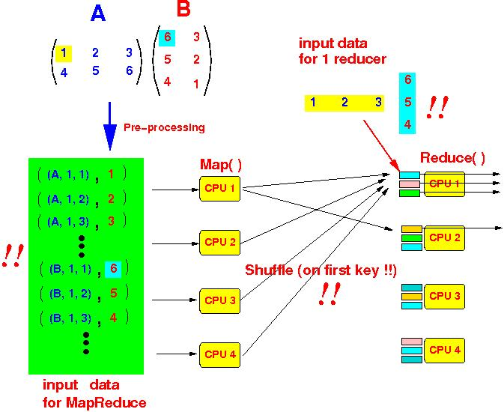
4
- Mapper:
  - Emits intermediate key-value pairs
  - Key = (i, j) position of result matrix
  - Value = partial multiplication values
- Reducer:
  - Aggregates values
  - Computes final sum for each element

🧰 Tools Required
- Hadoop (Cloudera / pseudo mode)
- Python (Hadoop Streaming)
- Linux terminal

⚙️ Algorithm
- Read matrices A and B
- Mapper emits:
  - For A: (i,k) → value
  - For B: (k,j) → value
- Shuffle and group by keys
- Reducer multiplies matching elements
- Sum results to form matrix C

💻 Program (Python MapReduce)

🔹 Input Format
A,i,k,value
B,k,j,value
Example:
A,0,0,1
A,0,1,2
B,0,0,3
B,1,0,4

🔹 Mapper Code
#!/usr/bin/env python3
import sys
for line in sys.stdin:
matrix, i, j, value = line.strip().split(",")
i, j, value = int(i), int(j), int(value)
if matrix == "A":
for k in range(2): # columns of B
print(f"{i},{k}\tA,{j},{value}")
else:
for k in range(2): # rows of A
print(f"{k},{j}\tB,{i},{value}")

🔹 Reducer Code
#!/usr/bin/env python3
import sys
from collections import defaultdict
current_key = None
A_vals = defaultdict(list)
B_vals = defaultdict(list)
for line in sys.stdin:
key, value = line.strip().split("\t")
if key != current_key and current_key:
result = 0
for k in A_vals:
for a in A_vals[k]:
for b in B_vals[k]:
result += a * b
print(f"{current_key}\t{result}")
A_vals.clear()
B_vals.clear()
current_key = key
tag, k, val = value.split(",")
k, val = int(k), int(val)
if tag == "A":
A_vals[k].append(val)
else:
B_vals[k].append(val)
# last key
if current_key:
result = 0
for k in A_vals:
for a in A_vals[k]:
for b in B_vals[k]:
result += a * b
print(f"{current_key}\t{result}")

▶️ Execution Steps
- Create input file:
nano matrix.txt
- Run Hadoop Streaming:
hadoop jar $HADOOP_HOME/share/hadoop/tools/lib/hadoop-streaming*.jar \
-input matrix.txt \
-output output_matrix \
-mapper mapper.py \
-reducer reducer.py
- View output:
cat output_matrix/part-00000

📊 Output
Example result:
0,0 11

✅ Result
Matrix multiplication successfully implemented using MapReduce.

📌 Conclusion
- Learned distributed matrix computation
- Understood how MapReduce handles complex operations

Experiment 4: MapReduce Program to Find Grades of Students

🎯 Aim
To develop a MapReduce program to calculate and assign grades to students based on their marks using Apache Hadoop.

📚 Theory

🔹 Concept
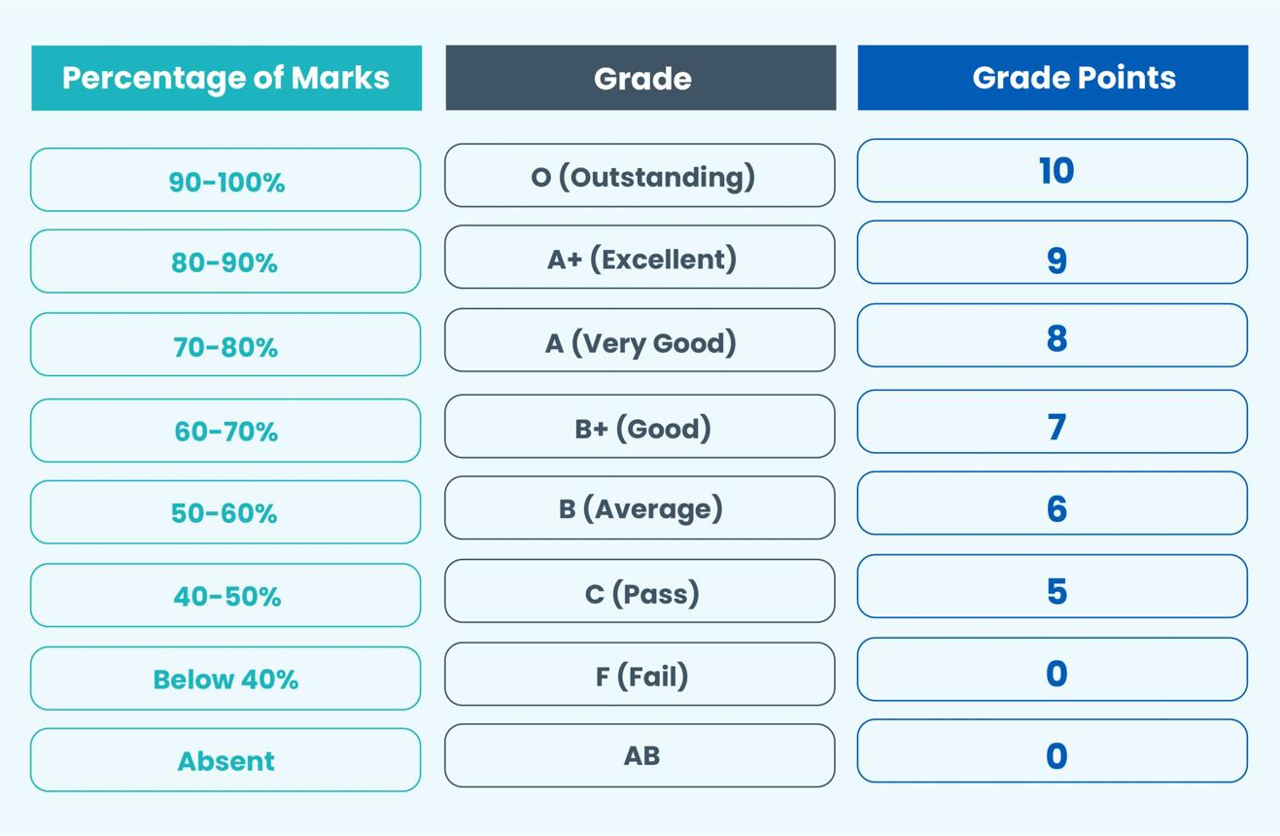
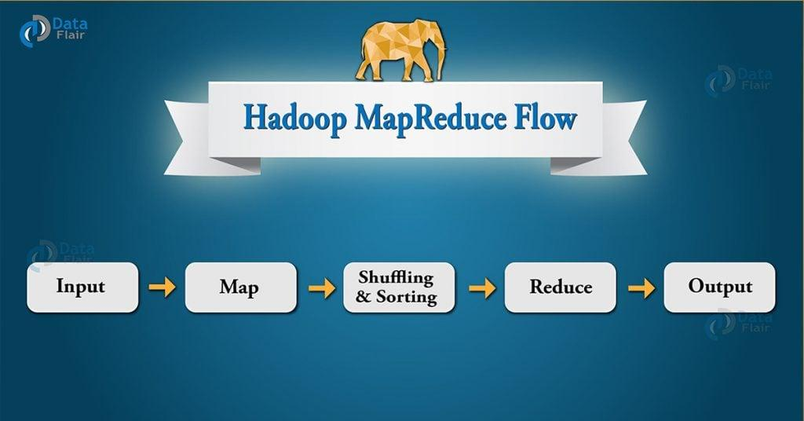

5
- In large datasets (like student records), grading can be efficiently done using MapReduce.
- The system processes marks and assigns grades based on predefined criteria.

🔹 Example Grading Criteria
Marks (%) | Grade
≥ 90 | A+
80–89 | A
70–79 | B
60–69 | C
50–59 | D
< 50 | F

🔹 MapReduce Logic
- Mapper:
  - Reads student name and marks
  - Emits (student, marks)
- Reducer:
  - Assigns grade based on marks
  - Outputs (student, grade)

🧰 Tools Required
- Hadoop (Cloudera / pseudo-distributed)
- Python
- Linux terminal

⚙️ Algorithm
- Read input file (student name, marks)
- Mapper emits (name, marks)
- Shuffle & sort by key
- Reducer assigns grade
- Display final result

💻 Program (Python MapReduce)

🔹 Input Format
Name,Marks
Example:
Rahul,85
Amit,72
Sneha,91

🔹 Mapper Code
#!/usr/bin/env python3
import sys
for line in sys.stdin:
line = line.strip()
if line:
name, marks = line.split(",")
print(f"{name}\t{marks}")

🔹 Reducer Code
#!/usr/bin/env python3
import sys
def get_grade(marks):
marks = int(marks)
if marks >= 90:
return "A+"
elif marks >= 80:
return "A"
elif marks >= 70:
return "B"
elif marks >= 60:
return "C"
elif marks >= 50:
return "D"
else:
return "F"
for line in sys.stdin:
name, marks = line.strip().split("\t")
grade = get_grade(marks)
print(f"{name}\t{grade}")

▶️ Execution Steps
- Create input file:
echo -e "Rahul,85\nAmit,72\nSneha,91" > students.txt
- Run Hadoop Streaming:
hadoop jar $HADOOP_HOME/share/hadoop/tools/lib/hadoop-streaming*.jar \
-input students.txt \
-output output_grades \
-mapper mapper.py \
-reducer reducer.py
- View output:
cat output_grades/part-00000

📊 Output
Amit B
Rahul A
Sneha A+

✅ Result
Successfully assigned grades to students using MapReduce.

📌 Conclusion
- Learned how to process student datasets using MapReduce
- Understood real-world application of Hadoop in education systems

Experiment 5: MapReduce Analysis of Titanic Dataset

🎯 Aim
To develop a MapReduce program to analyze the Titanic dataset and:
- Find the average age of male passengers who died
- Count number of female deaths in each class using Apache Hadoop

📚 Theory

🔹 Titanic Dataset Analysis
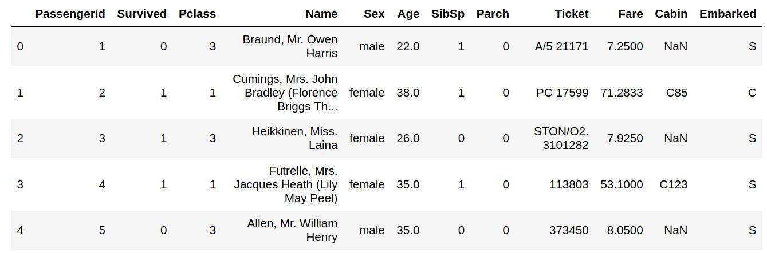
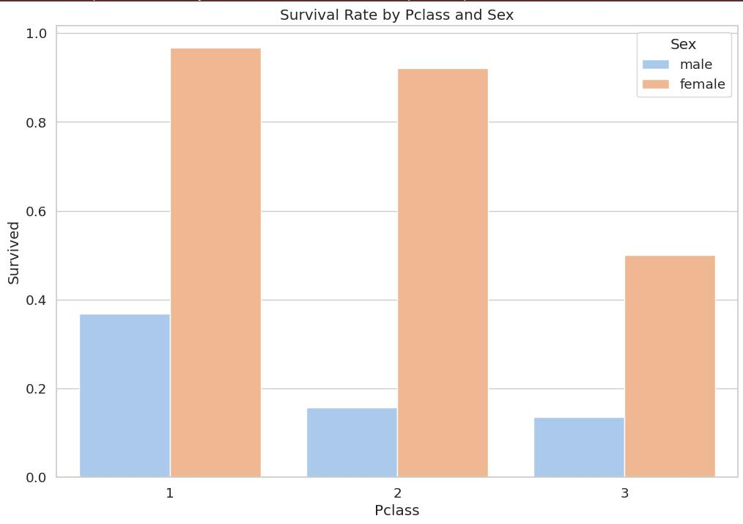
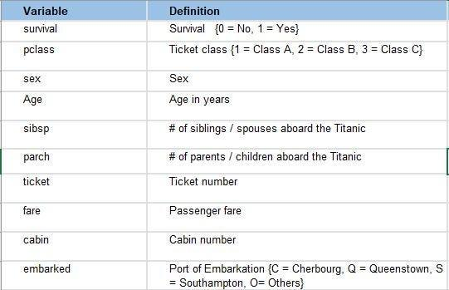
5
- The Titanic dataset contains passenger details such as:
  - Name
  - Age
  - Gender
  - Passenger Class (1st, 2nd, 3rd)
  - Survival status
- MapReduce helps process large datasets efficiently by distributing computation.

🔹 Problem Breakdown

✅ Task 1:
- Filter: Male passengers who died (Survived = 0)
- Compute: Average Age

✅ Task 2:
- Filter: Female passengers who died
- Group by: Passenger Class (Pclass)
- Count number of deaths

🧰 Tools Required
- Hadoop (Cloudera / pseudo mode)
- Python (Hadoop Streaming)
- Titanic CSV dataset

⚙️ Algorithm

🔸 Mapper
- Read each record
- Extract: Gender, Age, Survival, Class
- If male & dead → emit ("male", age)
- If female & dead → emit (class, 1)

🔸 Reducer
- For key "male":
  - Compute total age & count → average
- For class keys:
  - Count number of females dead

💻 Program (Python MapReduce)

🔹 Input Format (CSV)
PassengerId,Survived,Pclass,Name,Sex,Age,...

🔹 Mapper Code
#!/usr/bin/env python3
import sys
import csv
reader = csv.reader(sys.stdin)
for row in reader:
try:
survived = row[1]
pclass = row[2]
sex = row[4]
age = row[5]
# Skip header
if survived == "Survived":
continue
# Male dead → for average age
if sex == "male" and survived == "0" and age != "":
print(f"male\t{age}")
# Female dead → count by class
if sex == "female" and survived == "0":
print(f"class_{pclass}\t1")
except:
continue

🔹 Reducer Code
#!/usr/bin/env python3
import sys
current_key = None
total = 0
count = 0
for line in sys.stdin:
key, value = line.strip().split("\t")
if key != current_key and current_key:
if current_key == "male":
avg = total / count if count != 0 else 0
print(f"Average Age of Dead Males: {avg:.2f}")
else:
print(f"{current_key} Female Deaths: {total}")
total = 0
count = 0
current_key = key
if key == "male":
total += float(value)
count += 1
else:
total += int(value)
# Last key
if current_key:
if current_key == "male":
avg = total / count if count != 0 else 0
print(f"Average Age of Dead Males: {avg:.2f}")
else:
print(f"{current_key} Female Deaths: {total}")

▶️ Execution Steps
- Upload dataset:
hdfs dfs -put titanic.csv /
- Run Hadoop Streaming:
hadoop jar $HADOOP_HOME/share/hadoop/tools/lib/hadoop-streaming*.jar \
-input /titanic.csv \
-output /titanic_output \
-mapper mapper.py \
-reducer reducer.py
- View output:
hdfs dfs -cat /titanic_output/part-00000

📊 Output (Example)
Average Age of Dead Males: 31.62
class_1 Female Deaths: 3
class_2 Female Deaths: 6
class_3 Female Deaths: 72

✅ Result
Successfully analyzed Titanic dataset using MapReduce and obtained required insights.

📌 Conclusion
- Learned real-world dataset processing using Hadoop
- Performed filtering, aggregation, and grouping using MapReduce

Experiment 6: MongoDB – Installation, Database & CRUD Operations

🎯 Aim
To install and use MongoDB and perform CRUD operations (Create, Read, Update, Delete) on a database and collection.

📚 Theory

🔹 What is MongoDB?
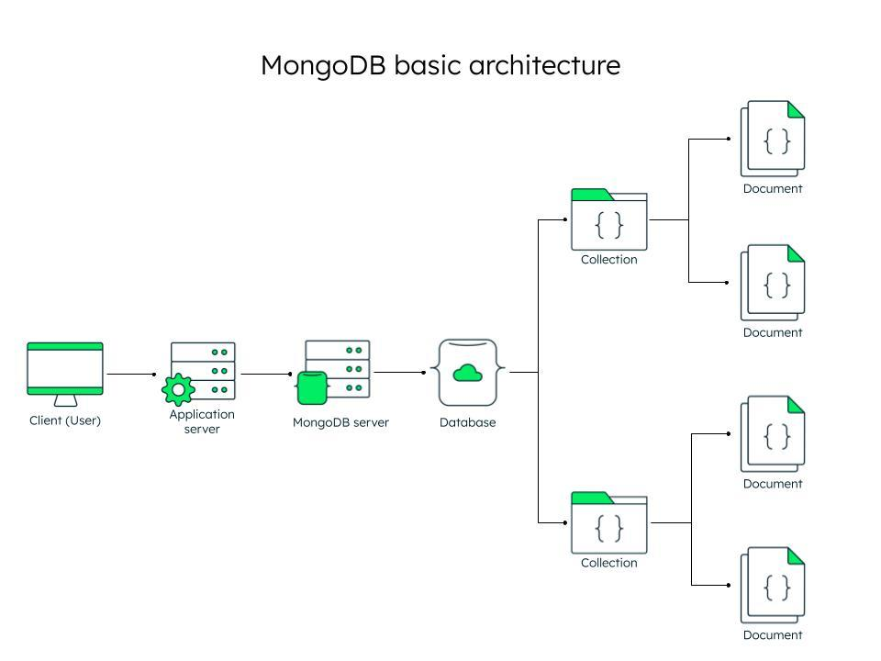
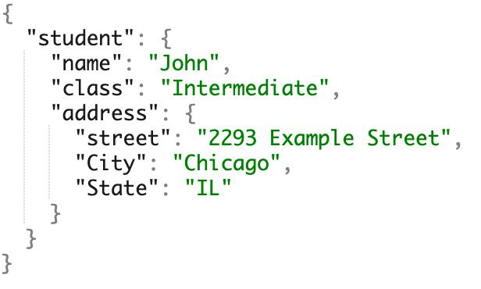
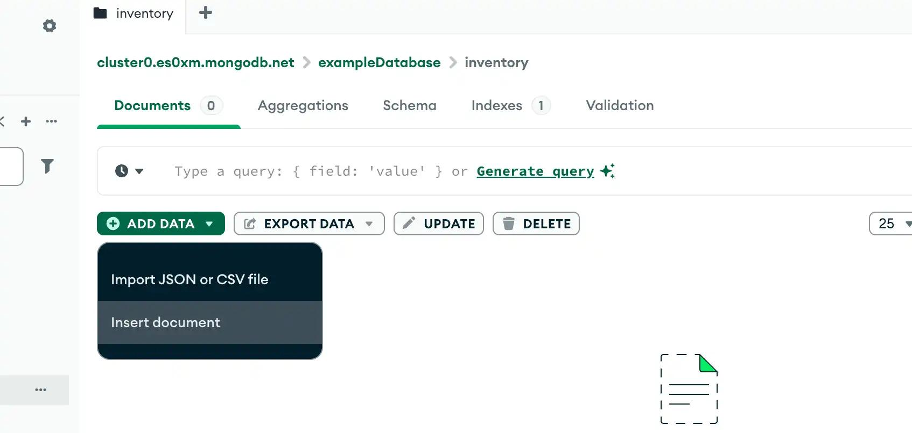
7
- MongoDB is a NoSQL database that stores data in JSON-like documents (BSON).
- It is schema-less and flexible.

🔹 Key Concepts
- Database → Container of collections
- Collection → Group of documents (like table)
- Document → JSON object (record)
Example:
{
"name": "Rahul",
"age": 22,
"course": "AI & DS"
}

🧰 Tools Required
- MongoDB Server
- MongoDB Compass / Mongo Shell
- Windows/Linux system

⚙️ Procedure

🔸 1. Installation
- Download MongoDB from official website
- Install and start MongoDB service
- Open terminal / command prompt

🔸 2. Start MongoDB Shell
mongosh

🔸 3. Create Database
use studentDB

🔸 4. Create Collection & Insert Documents (CREATE)
db.students.insertOne({
name: "Rahul",
age: 22,
course: "AI & DS"
})
db.students.insertMany([
{name: "Amit", age: 21, course: "AI"},
{name: "Sneha", age: 23, course: "DS"}
])

🔸 5. Query Documents (READ)
db.students.find()
db.students.find({age: 22})

🔸 6. Update Documents (UPDATE)
db.students.updateOne(
{name: "Rahul"},
{$set: {age: 23}}
)

🔸 7. Delete Documents (DELETE)
db.students.deleteOne({name: "Amit"})

📊 Output
- Documents inserted successfully
- Records displayed using find()
- Data updated and deleted correctly

✅ Result
Successfully performed CRUD operations in MongoDB.

📌 Conclusion
- Learned NoSQL database concepts
- Understood document-based data storage
- Performed real-time CRUD operations
窗体顶端
窗体底端

Experiment 7: Hive – Database, Table, Partition, Functions, Views & Index

🎯 Aim
To study and implement Hive operations such as database and table creation, partitioning, built-in functions, views, and indexing using Apache Hive.

📚 Theory

🔹 What is Hive?
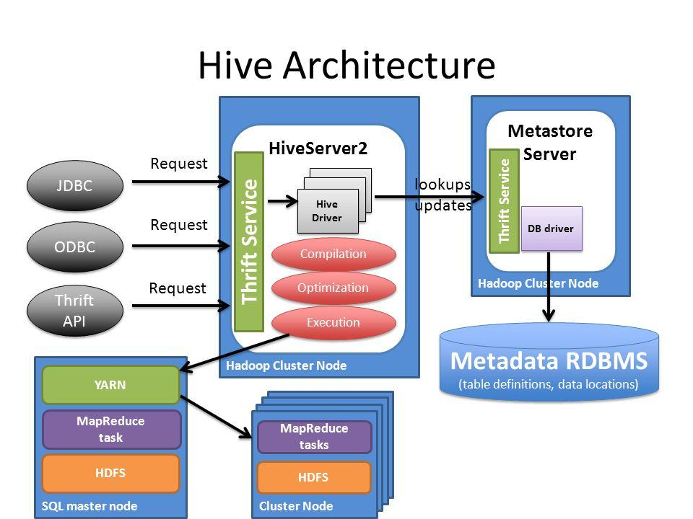
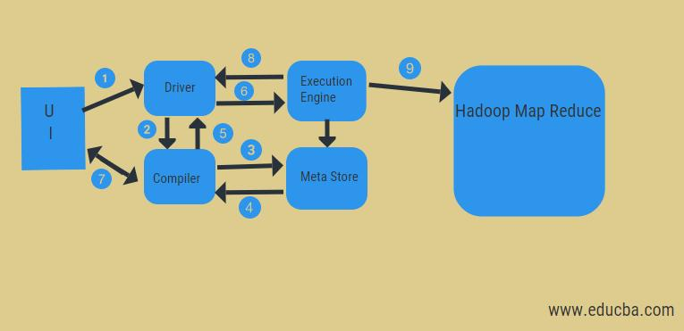
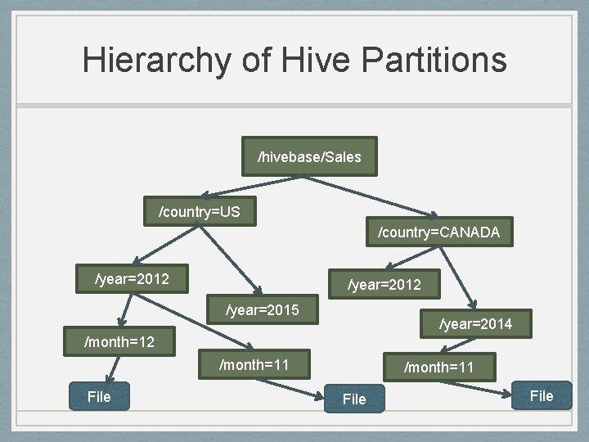
6
- Hive is a data warehouse system built on top of Apache Hadoop.
- It provides an SQL-like language called HiveQL.
- Queries are internally converted into MapReduce jobs.

🔹 Key Concepts
- Database → Logical namespace to store tables
- Table → Structured data in rows and columns
- Partition → Divides large tables into smaller parts
- View → Virtual table based on query
- Index → Improves query performance

🧰 Tools Required
- Hadoop with Hive installed
- Hive CLI / Beeline
- Linux system

⚙️ Procedure

🔸 1. Start Hive Shell
hive

🔸 2. Create Database
CREATE DATABASE studentDB;
USE studentDB;

🔸 3. Create Table
CREATE TABLE students (
id INT,
name STRING,
age INT,
course STRING
)
ROW FORMAT DELIMITED
FIELDS TERMINATED BY ',';

🔸 4. Load Data
LOAD DATA LOCAL INPATH '/home/hadoop/students.csv'
INTO TABLE students;

🔸 5. Hive Partition
CREATE TABLE students_partitioned (
id INT,
name STRING,
age INT
)
PARTITIONED BY (course STRING);
ALTER TABLE students_partitioned
ADD PARTITION (course='AI')
LOCATION '/user/hive/ai_data';

🔸 6. Built-in Functions & Operators
SELECT COUNT(*) FROM students;
SELECT MAX(age) FROM students;
SELECT UPPER(name) FROM students;

🔸 7. Create View
CREATE VIEW student_view AS
SELECT name, age FROM students WHERE age > 21;

🔸 8. Create Index
CREATE INDEX index_name
ON TABLE students (name)
AS 'COMPACT'
WITH DEFERRED REBUILD;

📊 Output
- Database and tables created successfully
- Data loaded into Hive table
- Queries executed using HiveQL
- Partition, view, and index created

✅ Result
Successfully implemented Hive database, table creation, partitioning, built-in functions, views, and indexing.

📌 Conclusion
- Learned Hive as a data warehouse tool
- Understood SQL-like querying using HiveQL
- Improved performance using partitions and indexing

Experiment 8: Data Visualization using Tableau / Power BI

🎯 Aim
To connect to data, build charts, analyze data, and create dashboards and stories using visualization tools like Tableau / Microsoft Power BI.

📚 Theory

🔹 What is Data Visualization?
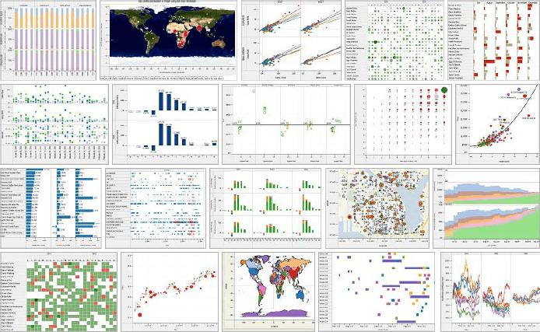
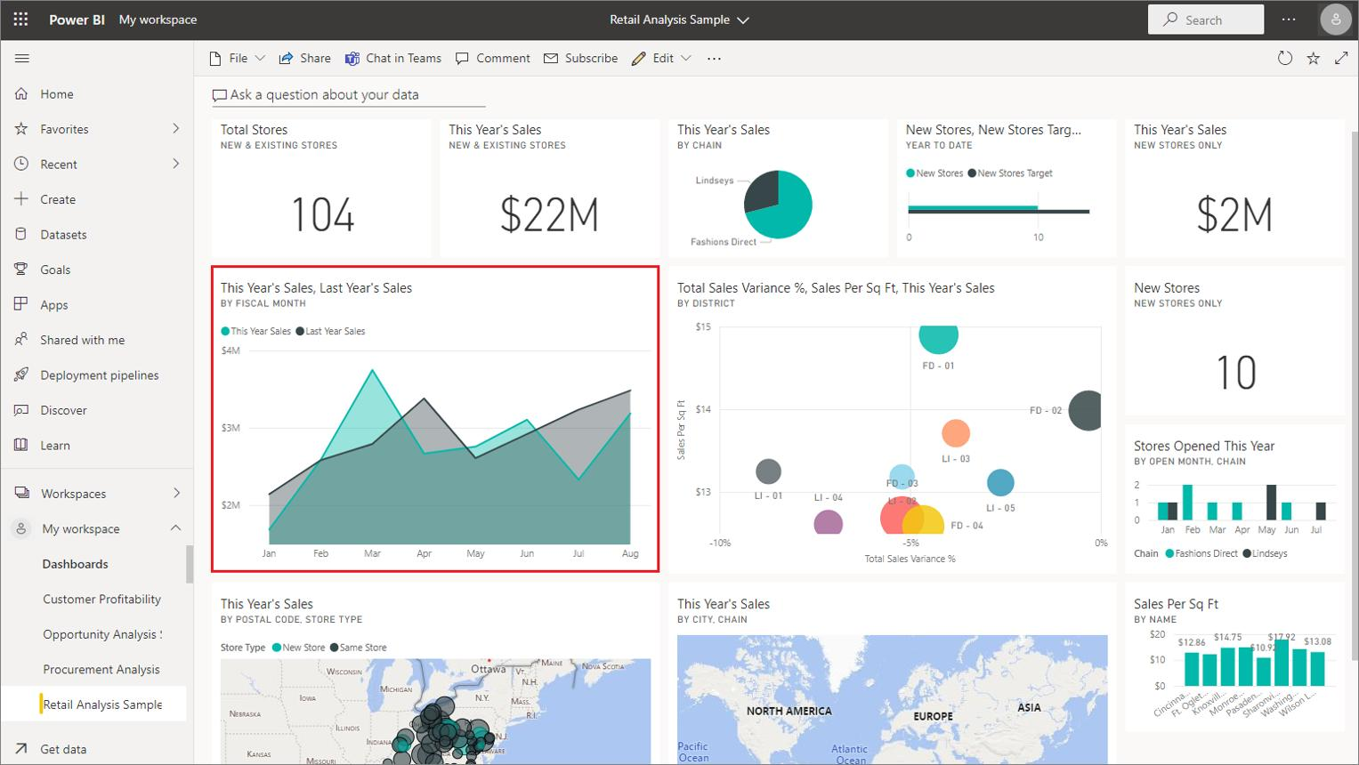
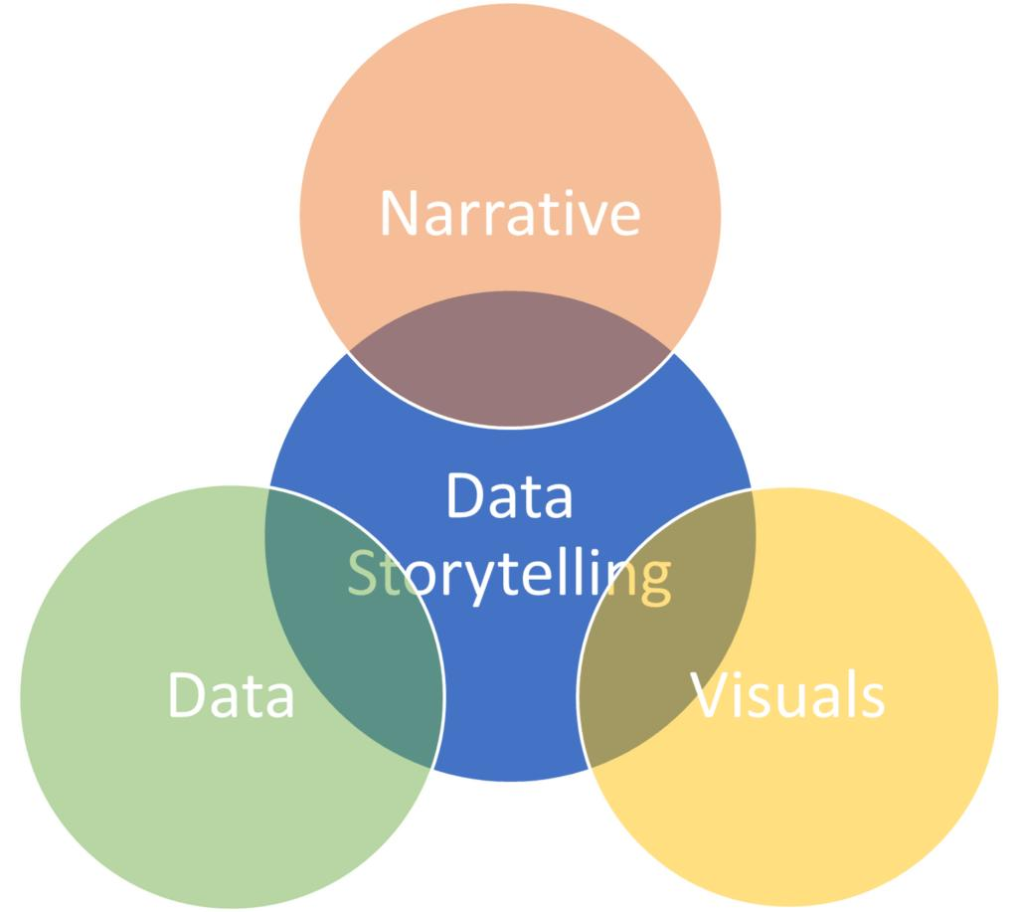
6
- Data visualization is the graphical representation of data using charts, graphs, and dashboards.
- It helps in understanding patterns, trends, and insights.

🔹 Tableau
- A powerful visualization tool for creating interactive dashboards
- Supports drag-and-drop interface
- Connects to multiple data sources

🔹 Power BI
- Developed by Microsoft
- Used for business analytics and reporting
- Provides real-time dashboards and insights

🔹 Key Concepts
- Data Source → Input dataset (CSV, Excel, DB)
- Charts → Bar, Line, Pie, etc.
- Dashboard → Collection of visualizations
- Story → Sequence of dashboards explaining insights

🧰 Tools Required
- Tableau / Power BI Desktop
- Dataset (CSV / Excel)
- Computer system

⚙️ Procedure

🔸 1. Connect to Data
- Open Tableau / Power BI
- Load dataset (CSV/Excel file)

🔸 2. Build Charts
- Create visualizations such as:
  - Bar Chart
  - Line Chart
  - Pie Chart
  - Histogram

🔸 3. Analyze Data
- Identify trends and patterns
- Apply filters and sorting
- Use aggregation functions (sum, average)

🔸 4. Create Dashboard
- Combine multiple charts
- Arrange visuals properly
- Add titles and filters

🔸 5. Create Story
- Create story points (slides)
- Add dashboards
- Explain insights step-by-step

📊 Output
- Data successfully connected
- Charts created for analysis
- Dashboard designed with multiple visuals
- Story created for data presentation

✅ Result
Successfully created visualizations, dashboards, and stories using Tableau / Power BI.

📌 Conclusion
- Learned data visualization techniques
- Understood dashboard creation and storytelling
- Gained insights from dataset using visual tools

